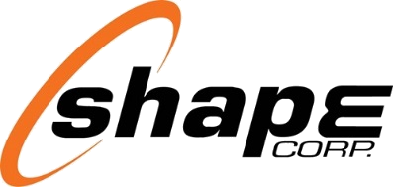
Shape Corp. 1900 Hayes St. | Grand Haven, MI 49417 | USA
Revision 6/1/2025 Document ID SCP-5330825

Contents
SECTION I. General Information 3
1.1 Shape Corp. Introduction 3
1.2 Shape Corp. Global Footprint 3
1.3 Document Purpose 4
1.4 Shape Code of Conduct 4
1.5 Diversity (regional specific) 5
SECTION II. Quality Expectations 6
2.1 General Expectations 8
2.2 Product Launch Requirements 8
2.3 Nonconformance and Corrective Action 12
2.4 Labeling & Documentation 14
2.5 Tooling and Gage Design/Build Standards and Calibration 19
2.6 Shape Corp Continuous Improvement 22
2.7 Automotive product-related software or automotive products with embedded software………………..23
SECTION III. Delivery Expectation 24
3.1 General Expectations 24
3.2 Shipping and Forecasting Schedules And Authorizations 24
3.3 EDI Transmission 25
3.4 Packaging Expectations 26
3.5 Logistics Expectations 26
3.6 Steel/Aluminum Coil Delivery 27
SECTION IV. Supplier Rating System 28
4.1 General Information and Objectives 28
4.2 Quality Section Overview 28
4.3 Delivery Section Overview 29
4.4 Partnership Section Overview 29
4.5 Performance Level Definition 30
SECTOIN V. Supplier Acknowledgement……………………………………………………………………………….31
5.0 Supplier Acknowledgement Form…………………………………………………….……………………………………………...31

general information

1.1 SHAPE Corp. iNTRODUCTION

Shape Corp. provides innovative engineering solutions with the discipline of flawless execution. The company is a full service, tier-one supplier that designs, engineers, tests and manufactures products in a variety of materials, including metals and plastics. Process and material advancements position Shape as a pioneer in custom roll forming and injection molding. Shape serves an array of industries including automotive, office furniture, medical and agriculture in more than 15 countries. Founded in 1974, Shape remains a privately owned, family company. Shape employs more than 3,000 associates globally, about whom Shape has adopted the slogan, “Thinkers, Believers, Doers.”
Shape Corp recognizes the importance of building strong partnerships with world-class suppliers. We are seeking partners who are interested in joining a high performance team committed to providing excellent customer satisfaction. The performance of our trading partners has a dramatic impact on our ability to exceed our customer’s expectations. Our goal is to have a positive impact on the performance and development of our suppliers. The pursuit of this goal will ensure on time delivery of defect free products and services.



1.2 SHAPE corp. GLOBAL FOOTPRINT
Shape Corp. has manufacturing facilities, engineering and sales offices, and joint venture locations in many locations, as shown below. Suppliers to Shape may be asked to deliver goods and services to one or more of these locations. The Shape Corp. Supplier Standards Manual applies to suppliers delivering to any Shape Corp. location or any location of a Shape Corp. affiliate (entities that are controlled by, under common control with, or control, Shape Corp.).

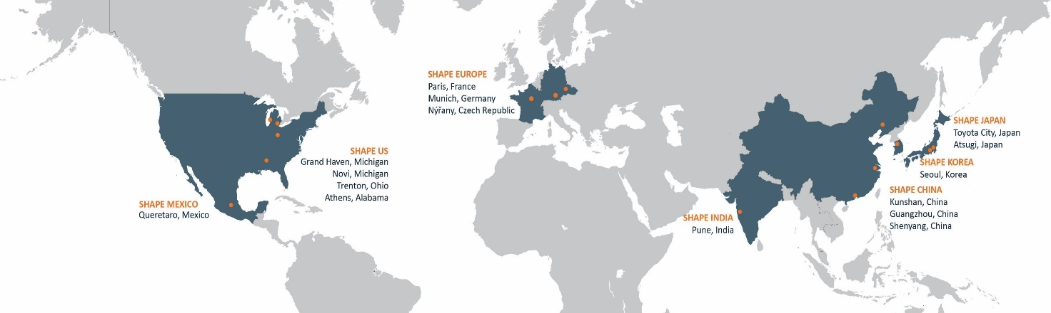

1.3 DOCUMENT PURPOSE
The purpose of this manual is to facilitate the communication of Shape Corp.’s requirements to its materials and component suppliers (other standards and manuals are available for services, tooling, and equipment suppliers to Shape Corp.). Kenneth Williamson
Shape Corp. requires that its suppliers:
- Acknowledge that a fundamental objective for quality and delivery performance is 100% achievement to written requirements.
- Manage facilities, processes, quality systems and personnel to consistently and cost effectively produce products supplied to Shape Corp. Key personnel changes such as but not limited to account managers, quality personnel, and plant management to be communicated to Shape Corp.
- Develop and implement advanced product quality planning, practices, and procedures in accordance with IATF16949 specifications, utilizing the AIAG Advanced Product Quality Planning (APQP), Failure Mode Effects Analysis (FMEA) and Control Plan reference manuals, unless otherwise specified by Shape Corp. and/or its customer.
- Provide objective evidence that supplied products satisfy all part approval requirements including acceptable process capabilities for all part characteristics that have been determined to be of significance.
- Utilize appropriate statistical techniques for on-going process control and improvement (as established in the AIAG Statistical Process Control / MSA manual).
- Be committed to continuous improvement in all areas by emphasizing variation reduction, process efficiency, and waste elimination.
- Operate an environmental management system which will observe the standard regulations applied nationally and, in the industry, (e.g., ISO14001), minimize the consumption of natural resources and meet the requirements of Shape Corp. (and its customers) for the recycling and disposal of the supplied products in a demonstrable manner.
- Meet Shape Corp.’s requirements regarding the use, control and supply of returnable packaging.
- Communicate all concerns or changes (engineering or otherwise) prior to implementation that may affect our business. Refer to change point control under section 2.2. Significance of the change and actions will be determined based on Shapes and/or our customers’ requirements.
- Adhere to the latest statutory and regulatory requirements for country of receipt, country of shipment as well as the country of destination, if we can provide.

1.4 SHAPE Principles OF CONDUCT

Shape believes its and our suppliers’ mutual interests are best served by a common dedication to excellence and ethical behavior. Shape’s suppliers are expected to follow Shape Supplier Principles of Conduct, locatable at www.shapecorp.com/suppliers. If Shape becomes aware of an alleged or actual non-compliance with the Supplier Principles of Conduct, Shape will initiate mitigation actions, including but not limited to:
    - New Business Hold
    - Audit or Investigation
    - Non-Conformance and Corrective Action
    - Termination for Breach/Nonperformance.

1.5 Diversity (regional specific)
Policy Statement
Minority/Veteran/Women Business Enterprises
Shape Corp. provides equal access to contracts and business opportunities to all entities capable of meeting the company’s needs and will attempt to procure goods and services from Minority, Veteran, and Woman-Owned Business Enterprises when possible.
“Minority Business Enterprise” shall mean a business that is at least 51% owned, controlled, and operated by a minority person. The business must be certified as a Minority with a recognized minority council or government organization to qualify.
“Veteran Business Enterprise” as defined by Military & Veteran Organization Task Force which issues certification based on qualifications found at NVBDCtaskforce.org.
“Women-Owned Business Enterprise” shall mean a business that is at least 51% owned, controlled, and operated by a woman. The business must be certified as a Woman with a certifying agency being Women Business Enterprise National Council-WBENC or government agency.
To support this policy statement, Shape will establish goals to have a certain minimum percent of its annual procurement spend directed to Minority, Veteran and Women-Owned Business Enterprises.

The Basic Components of our Supplier Diversity Program
Outreach |  | Participate in organizations that provide interaction with Minority owned enterprises (Any regional affiliate of the National Minority Supplier Development Council, Small Business Administration)
Certification |  | Verification of M/NVBDC/WBE status through certifications.
Qualification |  | Compare potential supplier capabilities with current and future procurement needs
Reporting |  | Providing our customers with feedback on our spend data
 | quality expectations

2.1 General Expectations
Shape Corp expects that all supplied products and services meet or exceed our quality expectations 100% of the time. We realize that our suppliers play a vital role in helping us in this effort. We do business with domestic and international automotive companies as well as many non-automotive customers. Customer specific requirements will supersede our requirements and will be communicated through the Shape Corp. program team. Suppliers must be compliant to Shape Corp and/or customer specific engineering and quality standards that are cascaded from Shape Corp. We expect regular communication from our suppliers to ensure that we are aware of problems and can work towards quick resolution with zero impact on our customers.

Quality standards and certifications:
We are committed to be certified to the highest required standards as specified by our customers. The requirement, for the automotive industry, is the IATF16949 Quality Management System. We expect suppliers involved in the production of automotive components to be certified at a minimum to the ISO9001:2015 standard and conforming to the current revision of IATF16949 requirements. Conformance to the IATF16949 standard is defined by the current IAOB published requirements.
Evidence of the valid certification is required and is to be provided to the Shape Quality and/or Commodity Manager at time of certification/recertification.
Our non-automotive suppliers are highly encouraged to obtain third-party quality systems certification by an RAB certified registrar.
Quality Certifications Requirements:
IATF and ISO:
- Suppliers are required to notify Shape Quality contact and/or Commodity Manager when a new/recertification is issued.
- Suppliers are required to notify Shape Quality and Purchasing Commodity Manager when a certification has been revoked or if the supplier has chosen to not re-certify to a standard within 24 hours of expiration.
Supplier Assessment:
- Shape requires an annual Supplier Assessment for select automotive suppliers.
  - The Supplier Assessment form will be distributed the first week of December, annually.
  - Suppliers are required to complete and return no later than January 15 of the following year.
- Where not required annually, suppliers will be required to complete this activity every 3 years.
- Shape reserves the right to conduct an onsite assessment and/or review of the assessment.
- The assessment will be retained in Plex with an expiration date per supplier.
NOTE: A written deviation, approval letter, or equivalent from Shape or Shape’s customer may be used if you are not certified to a quality system.

General purchased product workmanship standards
When not identified on a part print, all incoming raw material shall be delivered free of the following as it pertains to general Shape Workmanship Standards.
Coiled Raw Material:
Rust, Edge wave, ID (Inner Dimension) and OD (Outer Dimension) out of tolerance in any increment, Camber, Narrow strip width, cracking (micro and visible), and other visible damage.
Metal components/assemblies:
Rust on component or any part of assembly, warped or bent, burrs, and dimensionally “slightly out of spec”.
Plastic component/assemblies:
Flashing, blisters, burrs, sinking, incorrect gate trim, and dimensionally “slightly out of spec”.
Paint and Coating:
No coat, Light Coat, Boil out, drips, spits, blisters, oil/foreign material, and reworked surface down to raw material surface.

Plex utilization requirement
Suppliers are required to log into PLEX monthly for a variety of reasons including but not limited to:
- Update any contacts that might have changed within the organization.
  - Communicate changes in key roles within the supplier’s organization to the Shape Quality Contact and/or Shape Commodity Manager in addition to updating information in Plex.
- Obtain monthly scorecard after the 6th day of the following month.
- Keep plex credentials active after 60 days of no activity credentials void themselves for security purposes.
- Review/manage all Shape/Supplier concerns via the “problem control” menu.
- Receive any supplier related information releases. This will be present on the Plex Dashboard.
- Submit PPAP documentation via the Supplier PPAP module.
- Upload new certifications/recertifications and assessments.

enterproj utilization requirement (regional specific)
Where applicable, supplier APQP documentation is to be submitted through Enterproj.
The Shape ASQE or PSQ will work with chosen suppliers to establish a user login and provide training on how to use the system effectively.
PPAP elements, due dates, and KPIs, are all examples of what will be tracked in the Enterproj APQP module and will tie in directly to the Program Project Number that is established by Shape as part of the initial ER.

supplier gage and part calibration
Suppliers are required to manage and maintain all gaging (re)certification annually. If the gage is damaged in any way, the supplier shall notify the Shape Quality contact and work with a certified gage shop to address the concern if it is not able to be addressed in house. Examples of gage repair that is acceptable to be completed “in house” include replacement pin gage or other small tool change, replacing attachment features that hold pin or other gages, etc.
All fees associated with maintaining the gage are the responsibility of the supplier. Cost assumptions for the maintenance/validation should be part of the initial quote to Shape.
Shape retains the right to require that a full part and or gage layout via CMM is conducted on an as needed basis.

Supply chain sustainability (regional specific)
Shape Corp’s Sustainability vision is to become a LIGHTHOUSE ORGANIZATION in the automotive industry, leading the way in sustainability.
Shape expects all of our suppliers to comply fully with applicable laws, adhere to internationally recognized environmental, social and corporate governance standards, and to adhere to Shape’s Supplier Principles of Conduct.
Shape has established the following Green House Gas targets for our organization, aligned with many of our customers:
- 2025 Reduce carbon emissions by 30% in all global operations.​
- 2030 Carbon neutral operations. Source 100% renewable energy globally.​
- 2035 Shape is a carbon neutral company​.
- 2039 Carbon neutral products: sourcing-production-disposal.
Shape expects our strategic suppliers to implement sustainable business practices within their organizations, support our carbon reduction targets, and to cascade sustainable principles down their supply chain.
Shape encourages supplier product and process innovations to help Shape meet our sustainability goals. This includes the consideration of utilizing low or zero carbon raw materials, when available, to achieve the Carbon Free Products vision.
To support our supplier sustainability program, Shape requires the following actions from our strategic suppliers:
- Establish internal Green House Gas (GHG) reduction targets in alignment with Shape’s goal of being a carbon neutral company by 2035.
- Comply with prohibited or declarable substance laws: GADSL Global Automotive Declarable Substance List REACH Registration, Evaluation, Authorization and Restriction of Chemicals, and ECHA European Chemicals Agency.
- Upon request,
  - Report annual Scope 1 and Scope 2 carbon emissions (CO2e) for all sites manufacturing Shape products,
  - Supply a Conflict Minerals Reporting Template (CMRT) and Extended Minerals Reporting Template (EMRT),
  - Respond to Corporate Social Responsibility (CSR) surveys, and
  - Participate in Shape sponsored Supplier Sustainability working groups and education efforts.
Suppliers may report, anonymously or otherwise, suspected violations of law or business ethics within our operations without fear of retaliation using our Ethics Point hotline:
http://www.shape-corp.ethicspoint.com
Phone: (855) 866-3982

2.2 Product Launch Requirement
We realize that quality begins in the product launch process. Our business units and support staff utilize a launch structure to ensure all activities are completed to meet customer timelines. Ultimately, the Program Manager is accountable for the completion of the launch process. Contact the appropriate Program Manager or Commodity Manager/Buyer for details on this process.

Advance Product Quality Planning (APQP)
Requirements for APQP are based on the current revision AIAG Advanced Product Quality Planning and Control Plan (APQP) manual. However, the requirements are customized to the program, depending upon who the end customer is. In other words, customer specific requirements are incorporated. We communicate these requirements to the supplier through the Supplier Statement of Work (SSOW) and or Core Team Meetings between us and Supplier teams. It is the supplier’s responsibility to ensure that they have a full understanding of all requirements.

Production Part Approval Process (PPAP)
Generally, we utilize the current revision AIAG Production Part Approval Process (PPAP) manual format for part submission packages. Customer specific requirements (CSR’s) will ultimately dictate the content and format of part submissions. We are responsible for cascading the CSR’s and documenting the submission requirements, setting a timeline with due dates, and communicating them to the supplier. All questions and open items must be resolved prior to the submission due date with documented results included in the submission package as necessary.
All supplier PPAPs shall be signed off by a Shape ASQE or equivalent. PPAP will be approved based on all documentation being accepted.
During the final stage of the PPAP process, the Shape ASQE or equivalent shall award PPAP approval only as “interim” status until such a time that the Run at Rate is completed. This process does not prevent milestones from begin completed such as tooling payment, etc.
Regarding PPAP deliverable “Initial Process Study” (capability requirements):
Initial process study (part/process capability) shall be conducted by a 30-piece random sample from a run. Capabilities on high impact or controlled characteristics on a minimum of 30 pcs per cavity per line. Capability points are identified on the part print as “critical (CC) or safety (SC)” related. If no CC or SC is present, the supplier shall identify a minimum of 3 characteristics that are pertinent to manufacturability and perform the capability study. If capability is not achieved by submission due date, the supplier is required to provide a proposal to correct any issues along with an appropriate timeline to achieve capability.
Shape must approve timeline and effective countermeasures.

Engineering changes
Suppliers are required to comply with (and maintain on file) the current issued Shape Corp controlled drawing. When engineering changes occur, a drawing will be sent to the supplier from the Commodity Manager/Buyer.
Examples of Engineering Changes include but are not limited to:
- Tool location move.
- Supply chain changes.
- Part design changes.
- Process change.
Engineering Change Requests shall be submitted to Shape with the final customer minimum of 90 days prior to change, though when possible, all suppliers should be giving far more than 90 days to ensure enough time to complete activities.
Any suppliers wanting to initiate engineering changes may log onto www.shapecorp.com to access the Supplier Engineering Change Request form to complete and turn in the Shape Corp. Commodity Manager/Buyer or speak directly with the Commodity Manager/Buyer.

change point control
The table below explains each type of change type, lists some example changes (change type not limited to examples).
Note – a change in a part due to one of the listed types requires controls whether the change originates internally or externally to the supplier.

1 | Design Change | The part drawing changes, altering the physical structure of the part. A design change is done when a new part drawing or red pen is issued.
1 | Design Change | * New part design
1 | Design Change | * Design change that affects the part
1 | Design Change | *Design change that does not affect the physical structure of the part, such as part name or part number.
2 | New supplier | A supplier or sub tier supplier, who has never produced the part or component, manufacturing the part for Shape/Shape's customer
2 | New supplier | *Addition of a new supplier or sub supplier
2 | New supplier | *Changing the supplier or sub-supplier
2 | New supplier | * New delivery location
2 | New supplier | * Change from in house production to outside supplier (or vice versa)
2 | New supplier | * Change in factory location
3 | Material Change | The material(s) used to manufacture the part is changed.
3 | Material Change | *Change of material supplier
3 | Material Change | * Material supplier changed from outside to self-supplied (or vice versa)
3 | Material Change | * Change in material composition (including anti rust or lubrication oil)
4 | Manufacturing method change | A process method, setting, or condition used in manufacturing the part is changed or modified. This includes any change that effects the way parts are produced as reflected in the PPAP. This applies when the normal control range changes, not for routine adjustments.
4 | Manufacturing method change | * Casting or forging method change
4 | Manufacturing method change | * Sintering condition change
4 | Manufacturing method change | * Heat treatment condition change
4 | Manufacturing method change | * Rubber or plastic molding condition change
4 | Manufacturing method change | * Welding condition change
4 | Manufacturing method change | * Plating or coating condition change
4 | Manufacturing method change | * Machining and cutting condition change
4 | Manufacturing method change | * Process standards or setting method change
5 | Process order change | The manufacturing process order is changed or deviates from the PPAP
5 | Process order change | * Change to the order of the process or adding or deleting process steps.
5 | Process order change | *Change a temporary process to a permanent one (or vice versa)
6 | Machine Change | When the machine initially used to produce the parts during the approval process has been changed or replaced by another machine. Machines examples: stamping press, injection or blow molding, assembly line, etc.)
6 | Machine Change | * Initial use of the new machine
6 | Machine Change | * Major or minor modification or repair of a machine
6 | Machine Change | * Equipment relocation within the same plant or outside the plant or building.
6 | Machine Change | * Changes to the machine control logic (e.g., software upgrade or replacement that affects machine function)
7 | Jig/Tool Change | The primary or secondary tooling or jigs are changed, potentially affecting the quality, function, appearance, or reliability of the part. Jig and tool examples: welding or assembly fixtures used in manufacturing process, cooling fixtures, sonic or heat welding, etc.)
7 | Jig/Tool Change | * Change in machinery master for parts
7 | Jig/Tool Change | * New or modified jigs and tools
8 | Die/Mold Change | A die or mold that is used in the manufacturing process is new or changed
8 | Die/Mold Change | * New or renewed die or mold
8 | Die/Mold Change | * Revision or major repair of the die or mold
9 | Inspection Method Change | The inspection methods of the part are changed, potentially resulting in either an improvement or changes in the parts quality performance.
9 | Inspection Method Change | * New or modified inspection equipment
9 | Inspection Method Change | *Measuring method change or measuring instrument type change.
10 | Transportation/ Packaging Change | The method of transporting the part to Shape/Shape's customer or the packaging of the part deviates from the initial/back up approved method. The change could adversely affect the quality of the part.
10 | Transportation/ Packaging Change | * Change in delivery method, packaging materials or containers.

Early Production Product Containment
Product supplied to Shape during early production will be 100% sorted and contained for part validity per requirements set forth by Shape Corp. Supplier Quality Engineer or equivalent during the PPAP discussion. Safe launch documentation as defined by the Shape Corp. Supplier Quality Engineer or equivalent at time of the PPAP process. Data gathered shall be submitted to the Shape Corp. Supplier Quality Engineer or equivalent at a minimum frequency of weekly unless otherwise indicated by said engineer.
Any request to be removed from this activity shall be submitted to the Shape Supplier Quality Engineer prior to PPAP process for review. Supplier standards will be noted in our Supplier Statement of Work (SSOW) which will be issued to the supplier prior to the PPAP process. Early Production Product Containment/Safe launch containment is to be conducted for 90 Days pre and post SOP unless otherwise indicated by the Shape Corp. Supplier Quality Engineer or equivalent.
All suppliers are responsible to establish a “Fast Response Board” process which is to be put into place @ SOP- 3 months and carries throughout the production lifecycle of the product. The parameters for the Fast Response Board will be communicated by the Shape Corp. Supplier Quality Engineer or equivalent and results are to be given to said engineer upon request.

Additional Requirements
Suppliers are required to track product by our lot number system (or develop and record a correlation to Shape Corp’s lot control system) for the ability to segregate nonconforming material and minimize any impact that may incur. Lot traceability is the ability to separate material/product by batch, lot or run. Section 2.4 may also require the fields to be bar coded on the label as well for lot traceability.
Pass through characteristics and annual product validation may be required to be included on quality documentation (control plan). These pass thru characteristics are communicated and defined by the Shape Corp. Program Team. Statutory and Regulatory requirements must be followed where applicable on products for country of receipt, country of shipment as well as the country of destination, as required.

2.3 Nonconformance and Corrective Action

Supplier Nonconformance Process:
Nonconformance to our requirements (tooling, quality, documentation, and delivery) can impact our ability to meet customer expectations. The nonconformance, as well as the action taken by the supplier, is reflected on the Supplier Scorecard.
A problem record is issued when supplied product does not conform to the specifications be it part quality, process, delivery, etc. When a problem is issued, the supplier will be notified via Plex notification of CAR (Corrective Action Report) in conjunction with direct communication from a Shape Corp. representative.

The following are some examples of why a problem record may be issued:
- Nonconforming product found at our customer because of a Supplier’s product
- Nonconforming product found anywhere in our process - do not conform to the agreed upon specifications or standards (acceptance criteria is based on zero defects)
- The stated product quantity is not in the shipping container.
- Delivery of product is delayed.

Containment of nonconforming material
There are increasing levels of containment activity based on the severity of the issue, reoccurrence, and confidence in the corrective action presented. We expect that all suspect material is contained, and an interim corrective action is submitted to the business unit QE within 24 hours.
As part of the identification and containment process, the supplier shall put into place a “Fast Response Board” as part of the “Total Quality Wall” as described by SES (Shape Excellence System).
We will evaluate the non-conformance and determine the appropriate level of containment required. The two levels of containment activity and related guidelines are listed as follows:
LEVEL I CONTAINMENT is defined as the implementation of additional controls by the supplier to ensure all suspect products and/or documentation is verified to meet Shape Corp’s requirements. This action must include all product and/or documentation that may be in our facilities, in transit, in process, in a supplier storage location, or in any hold area. The goal of this containment is to purge the entire system of all non-conforming material. Supplier Level I Containment guidelines include the following:
- Containment area must have a well-defined material flow for incoming and outgoing product
- No rework must be done in the containment area
- Product acceptance, standards, measurements, and testing process to be agreed upon by Shape Corp QE or designate
- Results of containment activities must be documented in a report and submitted to the Shape Corp QE or equivalent who initiated the sort
- Containment personnel must be properly trained and have work instructions, quality standards, boundary samples, etc.
LEVEL II CONTAINMENT is defined as the implementation of additional controls by an impartial third party approved by Shape Corp, at the expense of the supplier; to ensure all suspect inventories are purged and/or verified. Level II containment is enacted when level I containment fails to protect us from receiving non-conforming material. Level II containment will result from any non- conforming product found at Shape Corp during the specified containment period at early product launch (i.e., GM GP-12 or equivalent). All Level I requirements apply to Level II with the additional requirements as listed below.
Supplier Level II Containment guidelines include the following:
- Shape will initiate Level II activities by sending a formal request to the supplier’s Plant and/or Quality Managers.
- All documents pertaining to the containment action must be certified by the third party involved (example: container labels, packing lists, sort reports)
- We may require that the supplier involve third party engineering services, at the supplier’s cost, if adequate progress is not being made on containing and correcting the incident.
- The supplier is required to submit all sort records and/or engineering findings to us to verify that appropriate containment and corrective action activity is taking place.

Removal from Containment
Removal from containment will be determined once supplier has completed the corrective actions and verified by Shape Corp. that they are implemented along with concrete data showing significant improvement.

cost recovery (regional specific)
In the event we experience down time, scrap, or labor expenses to sort or schedule additional labor hours due to supplied non- conforming material, etc., we will calculate all costs incurred related to the issue and debit the supplier on record through the Cost Recovery System in Plex. In the event of a Customer Impact, all costs associated will be cascaded to the supplier.
Potential sources of costs include but are not limited to:
- Line Down: To be calculated based on the specific cost for respective line.
- Sorting/Rework: Hourly charges for sorting or rework both at our plants and our customer.
- Product Cost: The total cost of a non-conforming assembly resulting from a supplier issue.
- Administrative fee: Quality Engineering, Leadership, and plant resource management of the NOK claim.
- Travel costs incurred by Shape Corp to contain the issue at our customer and or at the supplier site.
Additionally, any costs not identified above that are incurred by Shape due to the validated quality issue will be charged 100% to the supplier through such methods as a “Cost Recovery Debit”.

cost recovery: administration fee (regional specific)
Depending on the issue, additional routing and verification of parts i.e. extra spot checks that are not conducted on the line will be conducted which require additional personnel and data verification/review, etc.
At times these steps can be additional to an incoming inspection step at time-of-receipt of material, however Shape does not require incoming inspection for most of our purchased parts so this step in added administrative labor for various positions.
In addition, repeat issues will be escalated to Shape Supplier Development Management for intervention to aid the permanent closure of the concern.
The cost recovery for initial incidents will include a $500 administration fee.
For any repeat occurrence, the administration fee will be $1,000 administration fee based on the details outlined above.

return of nonconforming product (regional specific)
In the event supplied product has been verified as “nonconforming” to the known standard, a supplier return will be issued.
Depending on the issue, material may be returned to the supplier or “scrapped-in-house” at Shape.
The supplier has the right to request the nonconforming material be sent back to the supplier for review or that Shape scrap on the supplier’s behalf.
The Shape Quality Engineer or equivalent will request an RMA (Request for Material Authorization) prior to processing the Supplier Return.
RMA Response Requirement: Shape requires suppliers to respond to RMA requests within 5 business days.
In the event the supplier does not respond to the RMA/Recovery Authorization within the given time limit, Shape reserves the right to escalate the claim to Shape Purchasing Commodity Manager to assist with recovery.
Shape will request nonconforming parts identified at a Shape customer to be sent back to Shape and subsequently to Shape’s supplier.
Shape is committed to the idea that problem solving is most effective when a sample is at hand and will take all possible steps to retrieve the sample(s).
When nonconforming material is identified at a Shape customer it may be impossible to retrieve the sample due to the customer’s process. Shape may only be given a photo along with NOK data which Shape will provide to the supplier for problem solving. Shape asks that all efforts are taken by the supplier to problem solve with any information the customer can provide.

Problem Solving
The preferred corrective action form is the Corrective Action (8-D) and to be completed within Plex; the program teams may also request a specific corrective action format (i.e., 5-P, Global 8-D, 7 Step, etc.) to meet customer specific requirements. To get access to Plex, contact your Supplier Quality Rep at Shape Corp.
The supplier is responsible to:
- Respond to Shape with a documented containment action (how to contain the issue) and interim corrective action (actions that protect us until the corrective action is in place) within 1 day of the notification.
- Complete corrective action (not including intended verification actions) within 14 days of the notification, or communicate timeline expected to the appropriate personnel.
- Supplier is responsible to verify the corrective action is effective with at least 30 days of “clean point” and the overall problem solving to be closed in no more than 60 days.
- The Supplier Rating will be negatively affected if the corrective action response is untimely or unsatisfactory. Untimely and unsatisfactory responses can ultimately have a negative impact on potential future business with Shape Corp.
- Use problem solving tools such as 5 whys, A-3, and turtle diagrams to help determine the root causes for the occurrence, escape and the system failure(s)/weakness to keep reoccurrence from happening. The utilized method is to be attached to the CAR form in Plex along with any supporting evidence for True Root Cause.
- Complete the corrective actions, preventative actions along with the verification for the occurrence, the escape, and the system failure(s)/weakness relating to the root causes that were identified.
- Supplier is responsible to escalate any roadblocks to Shape Supplier Development team and seek any assistance to remove the roadblocks.
NOTE: Shape Corp. can provide an instruction to assist in the problem-solving process within Plex.

2.4 Labeling & Documentation

Container labels – All Suppliers
An integral part of our Material Control System is the ability to receive material and control inventory using bar-coding technology.
Shape may grant concessions allowing the supplier to use a different label format other than what is specified in this document if needed or required by our customers. If a subcontract supplier ships directly to our end customer, the end customer’s labeling requirements apply.
Suppliers are required to track product by our lot number system (or develop and record a correlation to Shape Corp’s lot control system) for the ability to segregate nonconforming material and minimize any impact that may incur. Lot traceability is the ability to separate material/product by batch, lot or run. Section 2.4 may also require the fields to be bar coded on the label as well for lot traceability. See the “EDI and Labeling Guidelines” for process details. The guidelines are available on our website at www.shapecorp.com/suppliers.

Additional details on this are listed on the following pages.
These labeling requirements correspond to Shape Corp’s unique requirements and are thus more restrictive than the AIAG standard.
Labeling Requirements
- Shape Corp asks its suppliers to use standard 4 x 6 AIAG container labels. All labels must meet the standard as provided in AIAG B-10 Trading Partner Label definition dated 5/95. Additionally, all labels must meet the requirements listed in this document.

- A unique lot number on each container of product received into Shape Corp will be used for lot traceability and inventory tracking.

  - Each lot serial number may be used no more than once. Serial numbers must be alphanumeric (no spaces).

- In most cases, Shape requires container labels for each container unit. Different label formats may be discussed and agreed upon in advance with Shape Corp logistics. Master and mixed labels may be used if needed. These labels must also meet our defined requirements.

- Suppliers are expected to acquire a three-character serial number prefix from Shape. Inclusion of this prefix shall be required in the serial number wherever the serial number is used. The maximum number of characters in a serial number is 13, including any start/stop characters and data identifiers.

  - Suppliers who do not know their serial number prefix should contact their Shape Buyer or Shape Supplier Quality Engineer.
  - Containers that are to be delivered to a Shape facility shall have a label on a MINIMUM of TWO SIDES of each container.

Example Label 1 – Components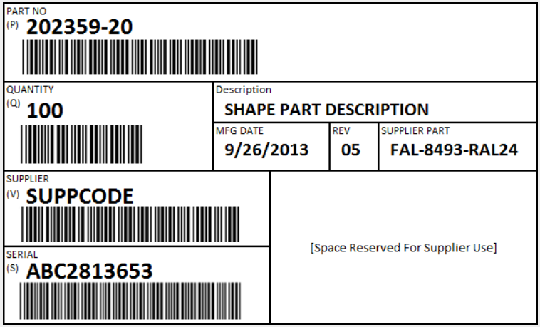
Example Label 2 – Raw Material
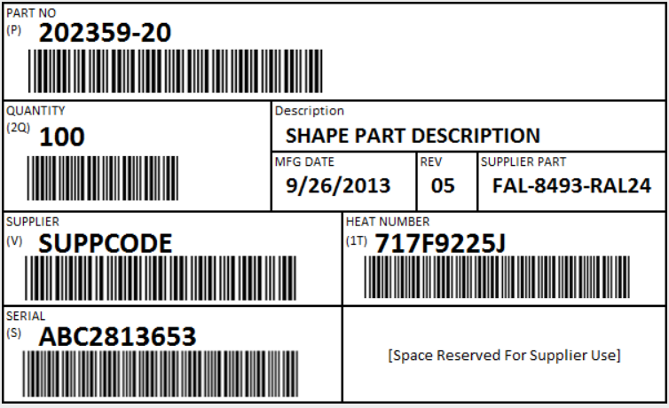
Example Label 3 – Master Units
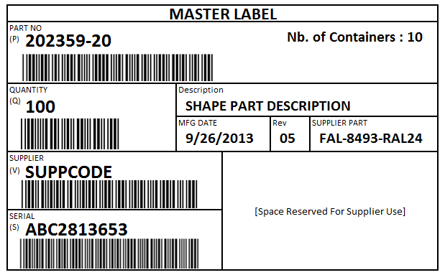
Example Label 4 – mixed Units
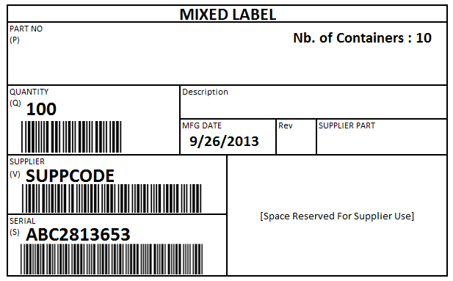
Labeling Field Descriptions
The tables below list out the fields to control on the AIAG Container Label.
For supplier EDI testing, write “OK” or “NOK” in the corresponding cell. In case of “NOK”, explain the precise reason in the “Remarks” column.
The column “Mandatory Y/N” indicates the mandatory data. In some cases, suppliers may be required to submit non-mandatory data in the ASN. Shape Corp reserves the right to require non-mandatory elements on a case-by-case basis.
For component shipments and shipments that do not contain raw materials, the labels shall contain the following information:
Container Shipping Labels
Field Description |  | Bar Code Manda- tory | Bar Code Prefix | Bar Code Format | Text Manda- tory | Conform OK/NOK |  | Remarks
 |  | Y / N | Bar Code Prefix | Bar Code Format | Y / N | Supp | Shape | Remarks
Supplier Name |  | No |  |  | NO | Ok
Supplier Address |  | No |  |  | NO
Supplier Code |  | Yes | V | 3 of 9 | YES
Part Number | 856  LIN-03 | Yes | P | 3 of 9 | Yes |  |  | Suffixes such as -20, -21, -70, and 71 are part of the part number & should be included.
Part Revision | 830 LIN-05  856 LIN-07 | No |  |  | Yes |  |  | Suffixes” such as -01, -03, -04 are revisions. Not to be used as part of the part number.
Part Description  Item description from Purchase Order | 830  PID-05 | No |  |  | Yes
Quantity | 856  CLD-02 | Yes | Q | 3 of 9 | Yes
Serial Number | 856  REF-02 | Yes | S | 3 of 9 | Yes |  |  | Include three letter supplier prefix
Shipper Number | 856  BSN-02 | No |  |  | NO |  |  | Shipper # should begin with 3 letter supplier prefix.
Date  Manufacturing Date or Shipping Date | 856  DTM*011  When ship date is used | No |  |  | Yes
Destination Location  Ship-to Address | 830  N1*ST-01, N3, N4 | No |  |  | NO

For raw material shipments such as steel coils and resin, the labels shall contain the following information:
Raw Material Shipping Labels
Field Description |  | Bar Code Manda-tory | Bar Code Prefix | Bar Code Format | Text Manda tory | Conform OK/NOK |  | Remarks
 |  | Y / N | Bar Code Prefix | Bar Code Format | Y / N | Supp | Shape | Remarks
Supplier Name |  | No |  |  | No
Supplier Address |  | No |  |  | No
Supplier Code |  | Yes | V | 3 of 9 | Yes
Part Number | 856  LIN-03 | Yes | P | 3 of 9 | Yes |  |  | Suffixes such as -20, -21, -70, and 71 are part of the part number & should be included.
Part Revision | 856/830  LIN-05 | No |  |  | Yes |  |  | Suffixes” such as -01, -03, -04 are revisions. Not to be used as part of the part number.
Part Description  Item description from Purchase Order | 830  PID-05 | No |  |  | Yes
Actual Weight | 856  CLD-02 | Yes | 2Q | 3 of 9 | Yes
Serial Number | 856  REF-02 | Yes | S | 3 of 9 | Yes |  |  | Include 3 letter supplier prefix
Lot/Heat Number | 856  REF*HC-02 | Yes | 1T | 3 of 9 | Yes
Shipper Number | 856  BSN-02 | No |  |  | No |  |  | Shipper No should begin with 3 letter supplier prefix.
Date  Manufacturing Date or Shipping Date | 856  DTM*011  When ship date is used | No |  |  | Yes
Destination Location  Ship-to Address | 830  N1*ST-01, N3, N4 | No |  |  | No
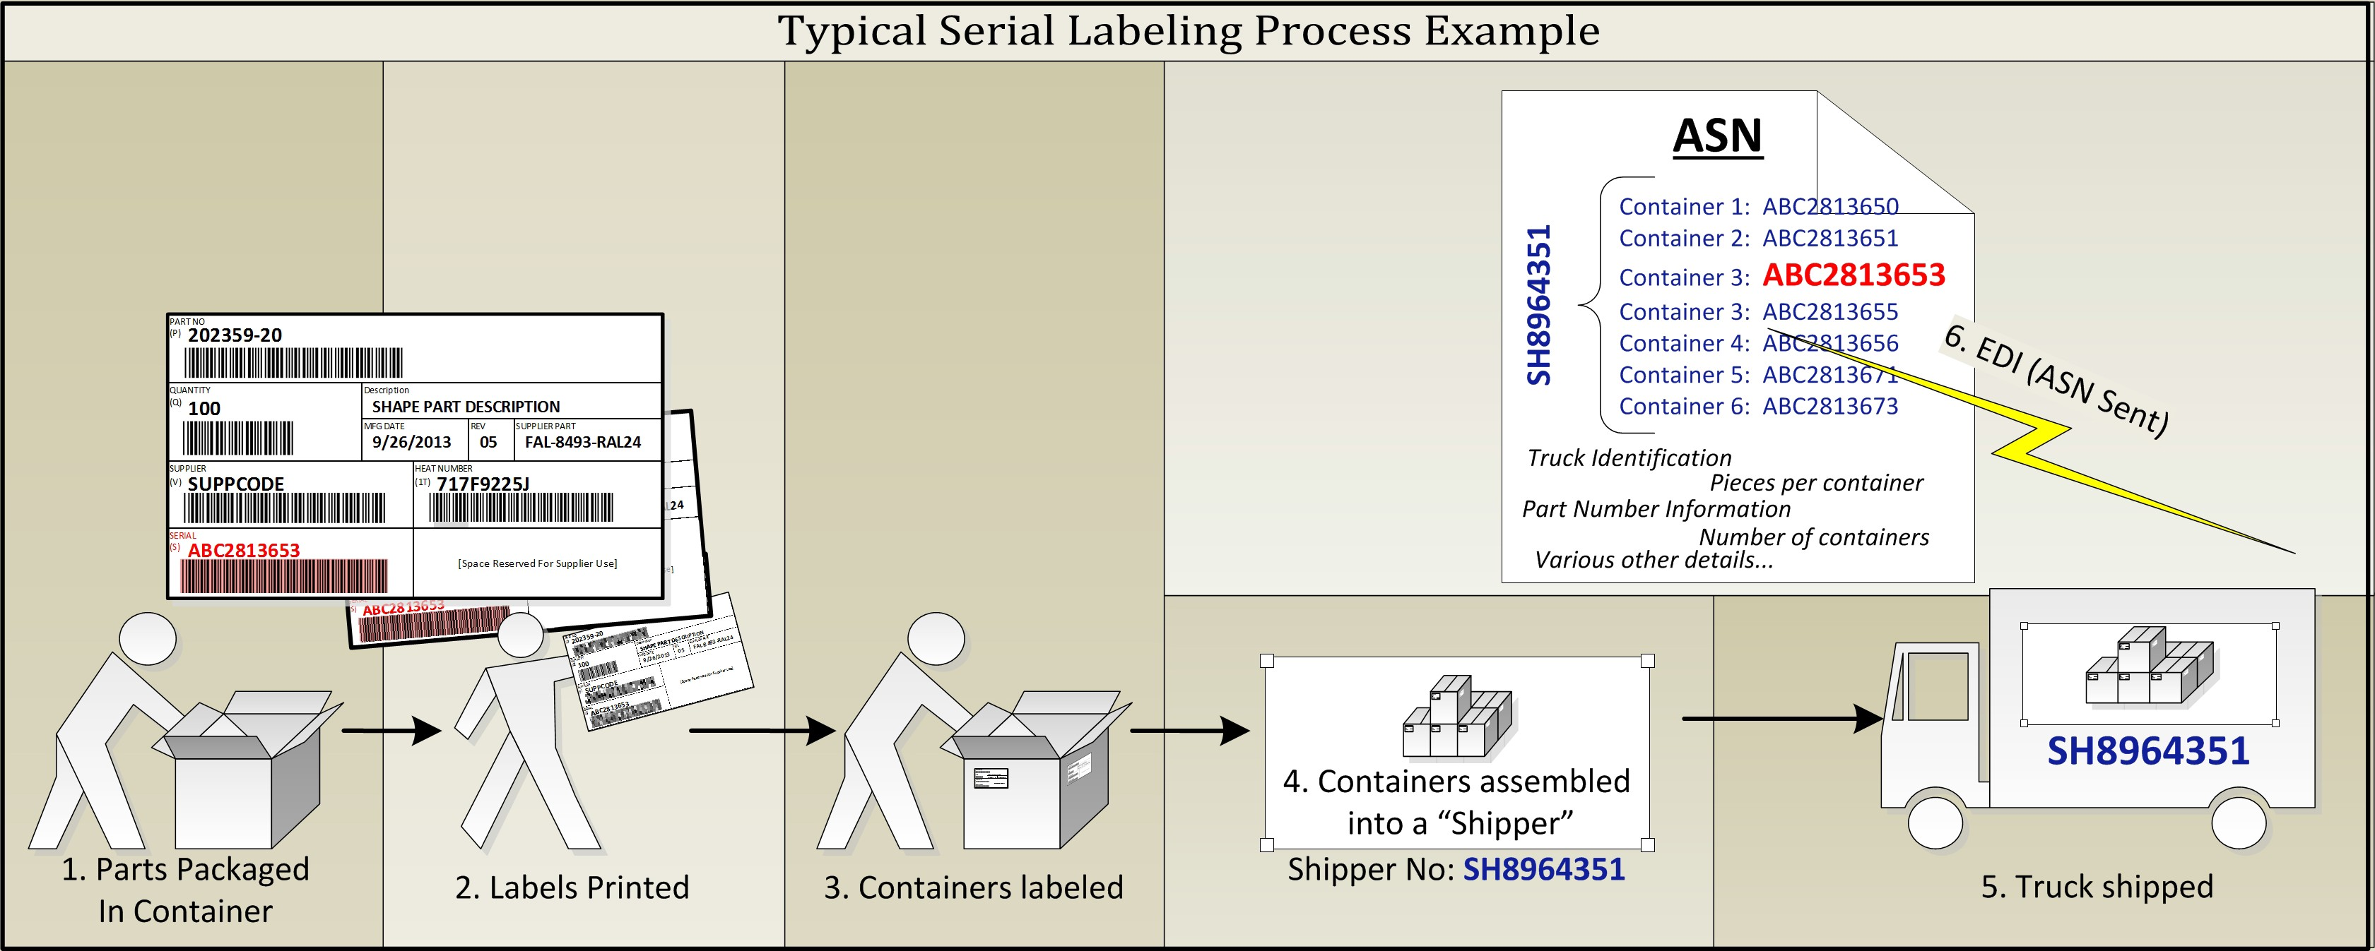
For shipments containing master units, the master labels shall contain the following information:
Master Shipping Labels
Field Description |  | Bar Code  Mandatory | Bar Code Prefix | Bar Code Format | Text  Mandatory | Conform OK/NOK |  | Remarks
 |  | Y / N | Bar Code Prefix | Bar Code Format | Y / N | Supp | Shape | Remarks
“Master Label” Heading |  | No |  |  | Yes
Supplier Name |  | No |  |  | No
Supplier Address |  | No |  |  | No
Supplier Code |  | No | V | 3 of 9 | No
Part Number | 856  LIN-03 | Yes | P | 3 of 9 | Yes |  |  | Suffixes such as -20, -21, -70, and 71 are part of the part number & should be included.
Part Revision | 830 LIN-05  856 LIN-07 | No |  |  | Yes |  |  | Suffixes” such as -01, -03, -04 are revisions. Not to be used as part of the part number.
Part Description  Item description from Purchase Order | 830  PID-05 | No |  |  | Yes
Quantity | 856  CLD-02 | Yes | Q | 3 of 9 | Yes |  |  | Total of all container quantities on the master unit
Number of Containers |  | No |  |  | Yes |  |  | Number of serialized containers on the master unit
Lot/Serial Number | 856  REF-02 | Yes | S | 3 of 9 | Yes |  |  | Include 3 letter supplier prefix
Shipper Number | 856  BSN-02 | No |  |  | No |  |  | Shipper No should begin with 3 letter supplier prefix.
Date  Must be Manufacturing Date or Shipping Date | 856  DTM*011  When ship  date is used | No |  |  | Yes
Destination Location  Ship-to Address | 830  N1*ST-01,  N3, N4 | No |  |  | Optional
For shipments containing mixed units, the mixed labels shall contain the following information:
Mixed Shipping Labels
Field Description |  | Bar Code  Mandatory | Bar Code Prefix | Bar Code Format | Text  Mandatory | Conform OK/NOK |  | Remarks
 |  | Y/ N | Bar Code Prefix | Bar Code Format | Y/ N | Supp | Shape | Remarks
“Mixed Label” Heading |  | No |  |  | Yes
Supplier Name |  | No |  |  | No
Supplier Address |  | No |  |  | No
Supplier Code |  | Yes | V | 3 of 9 | Yes
Part Number | 856  LIN-03 | Yes | P | 3 of 9 | Yes |  |  | Suffixes such as -20, -21, -70, and 71 are part of the part number & should be included.
Part Revision | 830 LIN-05  856 LIN-07 | No |  |  | Yes |  |  | Suffixes” such as -01, -03, -04 are revisions. Not to be used as part of the part number.
Part Description  Item description  from Purchase Order | 830  PID-05 | No |  |  | Yes
Quantity | 856  CLD-02 | Yes | Q | 3 of 9 | Yes |  |  | Total of all container quantities on the master unit
Number of Containers |  | No |  |  | Yes |  |  | Number of serialized containers on the master unit
Lot/Serial Number | 856  REF-02 | Yes | S | 3 of 9 | Yes |  |  | Include 3 letter supplier prefix
Shipper Number | 856  BSN-02 | No |  |  | No |  |  | Shipper No should begin with 3 letter supplier prefix.
Date  Must be Manufacturing Date or Shipping Date | 856  DTM*011  When ship  date is used | No |  |  | Yes
Destination Location  Ship-to Address | 830  N1*ST-01,  N3, N4 | No |  |  | No

Packing Slips
Incoming packing slips must contain the following:
- Ship date
- Packing slips must be legible
- Shape purchase order number – one purchase order per invoice
- Remit to Address, including telephone and fax number
- Shape Corp part number
- Description of product
- Quantity, unit of measure and number of containers
- Supplier packing slip number, which must also be referenced on the invoice
- Ship via and EXW
Overseas Incoterms will be determined on an as needed basis.
The above requirements are applicable to domestic shipments.
International shipments will follow all the above and are subject to additional requirements as needed.
Any packing slip, which does not comply with the above requirements, will affect the Delivery section of the supplier’s scorecard. Consequently, this may also delay payment due to incorrect or incomplete information in our system.
NOTE: Any sample material that is delivered to Shape Corp must be clearly identified as such.

Material Certifications
Material certifications may be required on components and raw material shipped to our facilities. The Purchase Order (P.O.) will list the appropriate specifications and any requirements for material certifications.
- The material certifications must accompany or be received in advance of the raw material receiving process.
- Raw material received without certification will not be placed into inventory until certification is received. The supplier is at risk of being charged a late delivery and may be liable for a line shut down and downtime/administration fees until certifications are received and material placed into inventory.
- Steel - HSLA (High Strength Low Alloy) grade of steel or higher must accompany mechanical test results as well as chemical test results and coating description (if applicable) on the certification.
- Steel – Below HSLA grade will require chemical data and coating description (if applicable) on the certification.

International Materials Database System (IMDS)
The purpose of this directive is to identify all conflicting materials and to determine recyclability of the vehicle at the end of its useful life. The IMDS is a database system where the material composition of parts, and how much of the part can be recycled, are entered, and tracked. AIAG has developed an industry standard method of collecting this data. It can be accessed, free of charge, at www.mdsystem.com Suppliers are expected to submit this data to the Shape Corp. Quality Engineer along with notifying us directly of any conflicting materials from the IMDS database.

2.5 TOOLING and Gage Design/Build Standards, Calibration, & Simulation
The Supplier Is Responsible To:
- In the circumstances where Shape builds or pays for a gage to be built on the outside, the expectation is that the supplier maintain, performs gage R&R, and calibrate unless otherwise noted on the SSOW.
- Notify Shape Corp prior to any major repair, replacing of non-maintained parts, or modification to tooling/gages that would affect the dimensions of product including a poor gage R&R.
- Shape Corp owned tooling/gages must be identified with customer and or Shape asset tag, to be coordinated with our Shape Corp. Program Team.
- Gages used on Shape Corp. parts must be calibrated per the calibration due date as stated on the gages/checking aids. This includes but not limited to check fixtures, calipers, mic’s, etc.
- Preventative maintenance established and in place for all tooling/gages.
- Inventory of spare parts for wearable items.

Stamping simulation requirements:
Upon award of business, the supplier shall provide the following information to Shape upon request by Product Development Engineer (PDE) or equivalent.
- Perform the forming simulation using AutoForm software or similar software.
- Provide overview report with documented feasibility concerns.
- Provide “.dynain” format output file with the following variables: Thickness, plastic strain, stress tensor, and strain tensor.

2.6 Shape Corp Continuous Improvement
The objective is to generate continuous improvement ideas that enhance product quality, reduce cost, and improve product value. It is a condition of continuing business that each supplier participates in. The cost down percentage is based as a percentage of supplier sales dollars from the previous year.
We have two fundamental and mutually exclusive areas where continuous improvements can occur:
- P.O. price reduction or sustainability
- Value Analysis Submissions/Continuous Improvement Activities
A Value Analysis idea is considered a change to the product resulting in the elimination of waste and cost savings. The change must either improve quality or be quality neutral.
Suppliers are encouraged to submit ideas to the respective Shape Corp Commodity Manager/Buyer. Performance in continuous improvement is a critical element of the supplier rating system and considered in all sourcing decisions. See section 4 for details on the supplier rating system.
In general, commodity generated cost reductions would not be given credit unless the supplier can demonstrate sustainability. The Shape Corp. Commodity Manager/Buyer ultimately has the responsibility to determine credit for ideas submitted within the continuous improvement program.

2.7 Automotive product-related software or products with embedded software
Suppliers providing product-related software or products with embedded software must maintain and implement a process for software quality assurance for their products. The documented information of a development capability self-assessment to be retained in your records.

Delivery Expectation

3.1 General Expectations
Missing a shipment to a customer is never an option. Our customers demand 100% on-time delivery of product and 100% accuracy of the information that accompanies the product. Meeting these expectations requires both a continual focus on the integration of data and systems throughout the supply chain and a continuous improvement approach to materials management. Integration of data and systems empowers the supply chain by providing the visibility necessary to operate a flexible but lean manufacturing process. Shape strives to improve supply chain performance through:
- Understanding and complying with industry standards such as the Materials Management Operations Guidelines (MMOG), published by AIAG.
- Utilizing continuous improvement teams focused on the development and implementation of best practices throughout Shape Corp.
- Frequent interaction with our customers to cascade requirements and allow mutual feedback on ways to drive waste out of the replenishment process.

3.2 Shipping and Forecasting Schedules AND AUTHORIZATIONS

- Shape Forecast, Release, and Authorization Types
Shape provides its suppliers the following data types:
- FORECASTS: Estimated demand developed from Shape’s analysis of actual customer orders and average sales of customer products, provided to suppliers whenever planning data is available, and for estimating purposes only. Forecasts are not a firm commitment by Shape Corp.

- MATERIAL RELEASES: Shape’s communication to its suppliers confirming quantities and delivery schedules to fulfill a previously issued Purchase Order. The due date listed on Material Releases indicates when parts are due. Pursuant to Shape’s Purchasing Terms and Conditions, all shipments must arrive at the time they are due. Shape reserves its rights detailed in Shape’s Purchasing Terms and Conditions in the case of late deliveries, which will also result in reductions to the supplier’s score under Shape’s Supplier Rating System.

- RAW AUTHORIZATION: The maximum number of weeks of a supplier’s inventory of raw materials or components for which Shape may reimburse a supplier, pursuant to Shape’s Purchasing Terms and Conditions, in the event Shape cancels a Material Release or terminates its Purchase Order. Standard RAW AUTHORIZATION is 8 weeks in addition to the FAB AUTHROIZATION time. Additional authorization may be negotiated at time of sourcing and listed in the Purchase Order.

- FAB AUTHORIZATION: The maximum number of weeks of fabricated goods in a supplier’s inventory for which Shape may reimburse a supplier, pursuant to Shape’s Purchasing Terms and Conditions, in the event Shape cancels a Material Release or terminates its Purchase Order. Shape will indicate its Fab Authorization for each supplier on its Purchase Order. Standard FAB AUTHORIZATION is 2 weeks. Additional authorization may be negotiated at time of sourcing and listed in the Purchase Order.

B. Shape Release Schedules
While Shape will communicate its schedules with suppliers that have not implemented EDI, Shape requires its suppliers to use EDI, which creates numerous benefits, including greater accuracy and reliability of Forecasts and standardized Material Release schedules, as illustrated in this table:
MATERIAL RELEASE SCHEDULE BY COMMUNICATION TYPE
 | EDI Material Release – 830 v4010 | Supplier Portal (non-EDI) Online Releases | Legacy (non-EDI) Schedules
Update Frequency | Monday through Saturday between 2:00 - 2:30 PM in the time zone of the ordering entity | In real time Monday through Saturday, Suppliers must check online releases daily 3:00 PM | Manual transmission by Shape planner
Number of weeks detailed | 3 weeks of daily Material Releases | Not standardized | Not standardized
Number of weeks summarized | 23 weeks of weekly Material Releases (Rare Customer specifics may alter) | Not standardized | Not standardized
Total weeks of Material Releases | 26 weeks | Not standardized | Not standardized

3.3 EDI Transmission
To exchange EDI with Shape, the Shape Corp EDI requirements must be followed. We have designed a clear process for implementing EDI. The EDI implementation process details can be found in the “EDI and Labeling Guidelines” document. Completion of this process is a prerequisite for trading EDI with Shape. The guidelines are available on our website at www.shapecorp.com/suppliers.
The following EDI documents are used for trading EDI:
- Material Release (830)
- ASN (856)
ASN must be sent within 30 minutes of the truck leaving the supplier’s dock.
- Late ASNs will result in the loss of points on the supplier scorecard
- If the ASN arrives after the truck has reached its ship-to destination, the ASN is considered late
If the ASN fails to send within the 30-minute window, an email must be sent to the Shape Material Planner with the following:
- Signed copy of Packing Slip
- Time of truck departure

EDI Information Process Flow

eCOM Integration Option for Pre-EDI suppliers
In some regions, i.e., the Asia Pacific region, Shape has partnered with eCOM to offer an EDI alternative for suppliers who have not yet implemented EDI. The eCOM portal allows suppliers to receive release schedules from Shape via EDI. The eCOM portal also provides suppliers with a tool for transmitting ASNs to Shape.
Suppliers may be held responsible for additional costs that result from their use of the eCOM service. Suppliers may avoid this additional cost by choosing instead to implement traditional EDI with Shape.
In summary, by using eCOM:
- Pre EDI suppliers can receive and view EDI releases via an online web interface
- Transmit ASNs to Shape

EDI Specifications
EDI specifications and EDI Guidelines are available at www.shapecorp.com/suppleirs.

Packaging Expectations
- The supplier is responsible to submit a sample package for approval by our Packaging Engineer. Contact the Shape Corp Packaging Engineer for a list of requirements for a specific product. NOTE: A container that is for handheld purposes must not exceed 35 lbs. for safety concerns.
- The supplier along with our Packaging Engineer will develop packaging for each part shipped into our facilities or directly to our customer.
- The supplier is responsible to have adequate alternative packaging as a contingency for unavailable primary packaging.
Any concerns with packaging development or supply should be addressed with our Packaging Engineer as soon as possible.

Logistics Expectations
- Suppliers will follow the Shape Corp’s routing instructions for all shipments. Routing instructions may be obtained from the Shape Corp Logistics Manager.
- The supplier must obtain an expedite authorization number from the appropriate Shape Corp Material Planner to deviate from the routing instruction.
- All premium freight shipments must have an authorization number from Shape Corp.
Any unauthorized premium freight or routing deviations will result in a debit back to the supplier.
- If we require a supplier to drop ship product (ship directly to a location other than Shape), proof of delivery must be provided to our receiving department within 24 hours of delivery.
- All current statutory and regulatory requirements are followed for country of receipt and country of shipment as well as the country of destination, if provided.
- If supplier misses shipment within lead time/promise date, supplier is responsible to secure and pay for expedited freight.

Steel/Aluminum Coil Delivery
All inbound trucks must be set up as rear unload. Any trucks side unloaded will be rejected at the dock. Edge falls/protectors are recommended for chains/straps to reduce/eliminate coil damage. Covered/tarped trucks are required, and any moisture will be documented/rejected upon receipt.

Laydown/skidded coils
- Coils on skids cannot exceed 10,000 lbs. No exceptions. This is a safety concern for our process.
- Coil widths under 12” are to be laid down on a skid.
- VCI paper, cardboard or equivalent is required between the coil and skid to prevent skid rust (steel).
- 1” spacers between each coil if multiple coils are stacked on a skid.
- Tails of the coils, inside of the inner diameter, must lay flat to a maximum of 2” from ID lap.

Stand up coils
- Coil widths 12” or above are to be stand up with the “eye” facing the rear of the truck.
- Maximum of 2 coils banded together (where applicable) due to weight restrictions of cranes/hoists/lift trucks.
- Tails of the coils, inside of the inner diameter, must lay flat to a maximum of 2” from ID lap.
NOTE: Failure to follow the above could result in a rejection of shipment.

Supplier Rating System

4.1 GENERAL INFORMATION and Objectives
Shape Corp. will evaluate its suppliers monthly according to a 100-point Supplier Rating System. The subsections below will be managed by Shape Corp’s Purchasing Department and will be based on feedback from Shape’s Program Managers, Quality Engineers, Buyers, Material Planners, and other associates as needed. The rating system is published monthly in the Plex portal for review.
The objectives of Shape Corp.’s Supplier Rating System are to provide our suppliers with feedback of their overall performance to our expectations, identify and prioritize supplier development needs as well as serve as a key element of our strategic sourcing process.

The maximum score of 100 points is applied to (direct buy unless specified) suppliers at the start of the month.
Once the calendar month has completed, each supplier’s performance is applied to the metrics below to generate the score for each section.
The rating system is comprised of 3 sections:
- Quality 35 max points
- Delivery 35 max points
- Partnership 30 max points

4.2 Quality Section Overview total points 35
- The maximum number of points for this section is 35 and is comprised of the following:
  - Number of Incidents (15 pts)
Number of Incidents | Score
0-0 | 15
1-2 | 5
3 + | 0
  - PPM (10 pts)
Quality PPM | Score
0 - 10 | 10
11-30 | 7
31 - 300 | 3
301 + | 0
  - Initial CAR Acceptance (10 pts)
Initial Acceptance | Score
0 - 0 | 10
1 + | 0

4.3 Delivery Section Overview total points 35
- The maximum number of points for this section is 35 and is comprised of the following:
  - Number of Delivery Incidents (15 pts)
Number of Incidents | Score
0-0 | 15
1-2 | 5
3 + | 0

  - Shape/Customer line Impact (15 pts)
Number of Impacts | Score
0-0 | 15
1-1 | 5
3 + | 0

  - EDI Compliance (5 pts)
Initial Acceptance | Score
0 - 0 | 5
1 + | 0

4.4 Partnership total points 30
- The maximum number of points that can be earned is 30 for this section.
- If any of the following scoring section (other than Cost Competitiveness) falls below the maximum amount, the company will be monitored for 3 consecutive months and Supplier Development management may reach out to work out a plan for increasing the score to be 100% compliant.
- This section scoring will be comprised of
  - Safety (5 pts)
  - Top Management Commitment (5 pts)
  - Cost Competitiveness (5 pts)
  - Sustainability/CSR (Corporate Social Responsibility) (5 pts)
  - Risk Management (5 pts)
  - Certificate Compliance (5 pts)

4.5 Performance Level Definition
The total points scored through the Supplier Rating System will determine the Performance Level of the Supplier. There are four Performance Levels, with the following resulting consequences:
• Level 1 (85-100): Suppliers performing at this level will be given every opportunity to quote Shape Corp. business opportunities that fall within their capabilities.
• Level 2 (70-84): Suppliers performing at this level for at least one month shall be monitored for 2 additional consecutive months. The supplier is responsible for increasing their overall score to a minimum of 85. This can be accomplished with the assistance of Shape Supplier Quality and Supplier Development support. A Supplier Development plan may be established by the Supplier Development department should it be necessary.
• Level 3 (50-69): Suppliers performing at this level for two consecutive ratings will be subject to a Shape Corp. management review of all current business. All actions from level 2 are applied at this level.
• Level 4 (<50): Suppliers performing at this level at any instance will be subject to immediate “future business hold” with Shape Corp. and a management review of all current business may result in resourcing.
All actions from level 2 are applied at this level with the addition of mandatory intervention of Supplier Development/purchasing.

5.0 Supplier acknowledgement
The Supplier Acknowledgement form is intended to provide evidence that the supplier has acknowledged the receipt of this document.
Supplier is required to sign and return this acknowledgement form to the Shape Supplier Development Manager within the give timeframe in the distribution email.
This acknowledgement form shall be retained by Shape in plex within the supplier’s “Profile”.
Each new revision of the Supplier Standards Manual will require a new Supplier Acknowledgement form following this practice.

Doc Revision ID: 5/1/25

______________________________________________________ ____________________________________
Supplier Signature Date

_____________________________________________________________________________________________
Signer’s Role

